An Example of Abstract for “WCRP/SPARC SATIO-TCS joint workshop”

Shigeo YODEN
Email: yoden@kugi.kyoto-u.ac.jp
Department of Geophysics, Kyoto University
Kyoto, 606-8502, Japan

This is an example of abstract which should be submitted for “WCRP/SPARC SATIO-TCS joint workshop on Stratosphere-Troposphere Dynamical Coupling in the Tropics”, which will be held in February 21 (Fri) - 25 (Tue), 2020 at Kyoto University, Kyoto, Japan.
Please visit http://www-mete.kugi.kyoto-u.ac.jp/Kyoto2020/ to download a sample file of a Microsoft Word document or its PDF file, and prepare your own abstract (maximum two pages) in the same format as this page, or you may use this file directly. Abstracts should be written in Times New Roman 11, single line spacing, full justified. Only the title is 12-point boldface Times New Roman typeface. Additional tables, graphs and figures could also be included.
Please upload your abstract with your registration information at http://www-mete.kugi.kyoto-u.ac.jp/Kyoto2020/ (through Abstract Submission and Registration page). The deadline for abstract submission is as follows:
Important dates
- Deadline for abstract submission with grant application: November 30, 2019
- Deadline for abstract submission: December 20, 2019
- Deadline of online registration: January 31, 2020
………..
………..
………..
………..
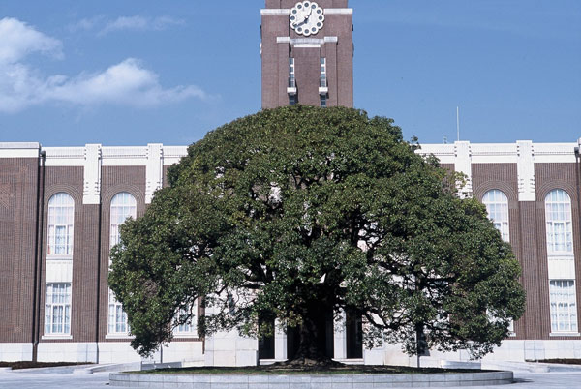
Figure 1 This is a photo of Clock Tower Centennial Hall (Front), Kyoto University. Color plots may be in gray tones in the printed version of of abstract collections.
………..
………..

